**Challenge 10**

[www.pythonchallenge.com/pc/return/bull.html](http://www.pythonchallenge.com/pc/return/bull.html)

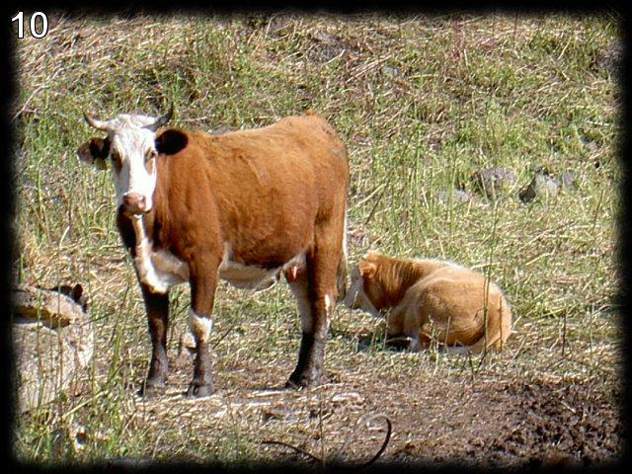  
  
Clicking on the picture takes you to the page . . . sequence.txt:

*a = [1, 11, 21, 1211, 111221,*

I plugged this into oeis search and this sequence has a name: ‘Look and See.’ It’s a popular recreational math sequence. The idea of the sequence is that it starts with 1 and the next numbers is the previous number read aloud: 1=’one 1’ 🡪 11=’two 1s’ 🡪 21=’one 2 one 1’ 🡪 1211=’one 1 one 2 two 1s 🡪 111221 . . .

These get very long very fast so the answer we are looking is the length of a[30], which is 5808. Putting 5808 in place of bull takes us to the next challenge.